**CREATE:**

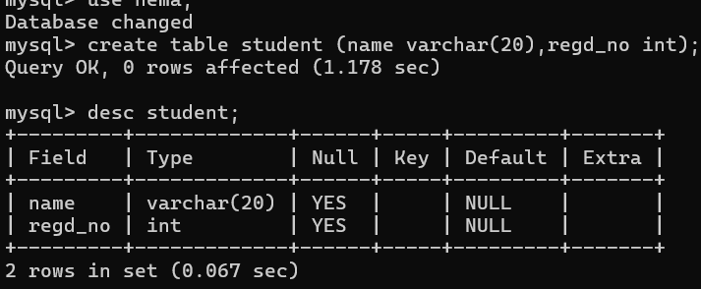

**ALTER:**

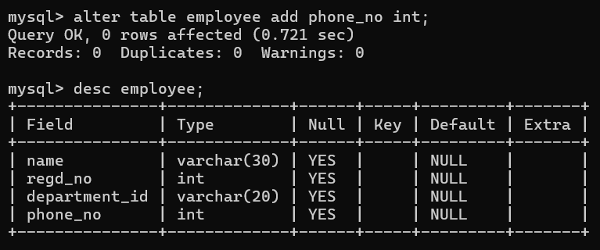

**TRUNCATE:**

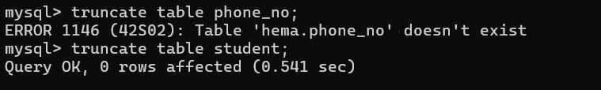

**DROP:**

